### **Distance Measures**

**Question 1**:

Consider the following three vectors u, v, w in a 6-dimensional space:

u = [1, 0.25, 0, 0, 0.5, 0]   
v = [0.75, 0, 0, 0.2, 0.4, 0]   
w = [0, 0.1, 0.75, 0, 0, 1]

Suppose cos(x,y) denotes the similarity of vectors x and y under the cosine similarity measure. Compute all three pairwise similarities among u,v, w.

Ans.

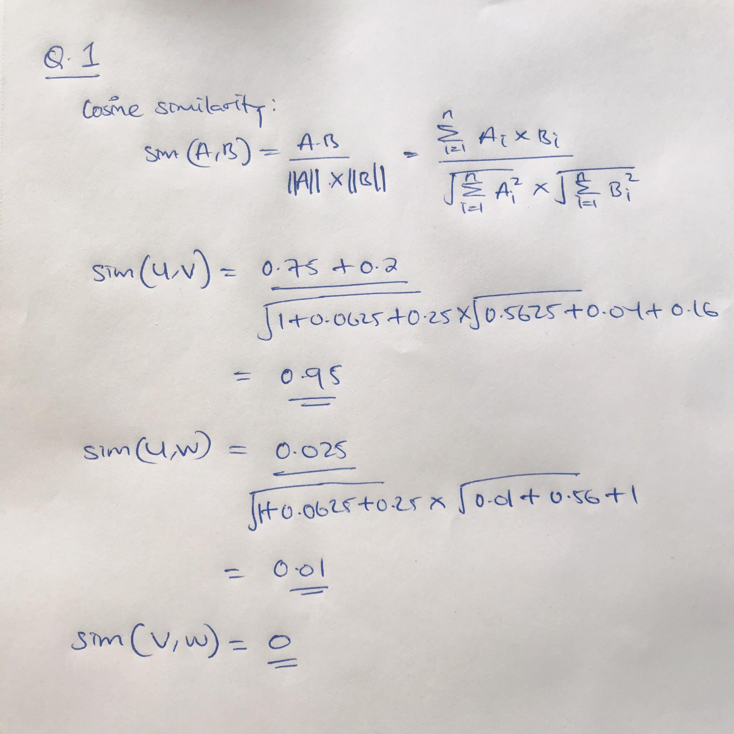

**Question 2**:

Here are five vectors in a 10-dimensional space:

1111000000 0100100101 0000011110 0111111111 1011111111

Compute the Jaccard distance (not Jaccard "measure") between each pair of the vectors.

Ans.

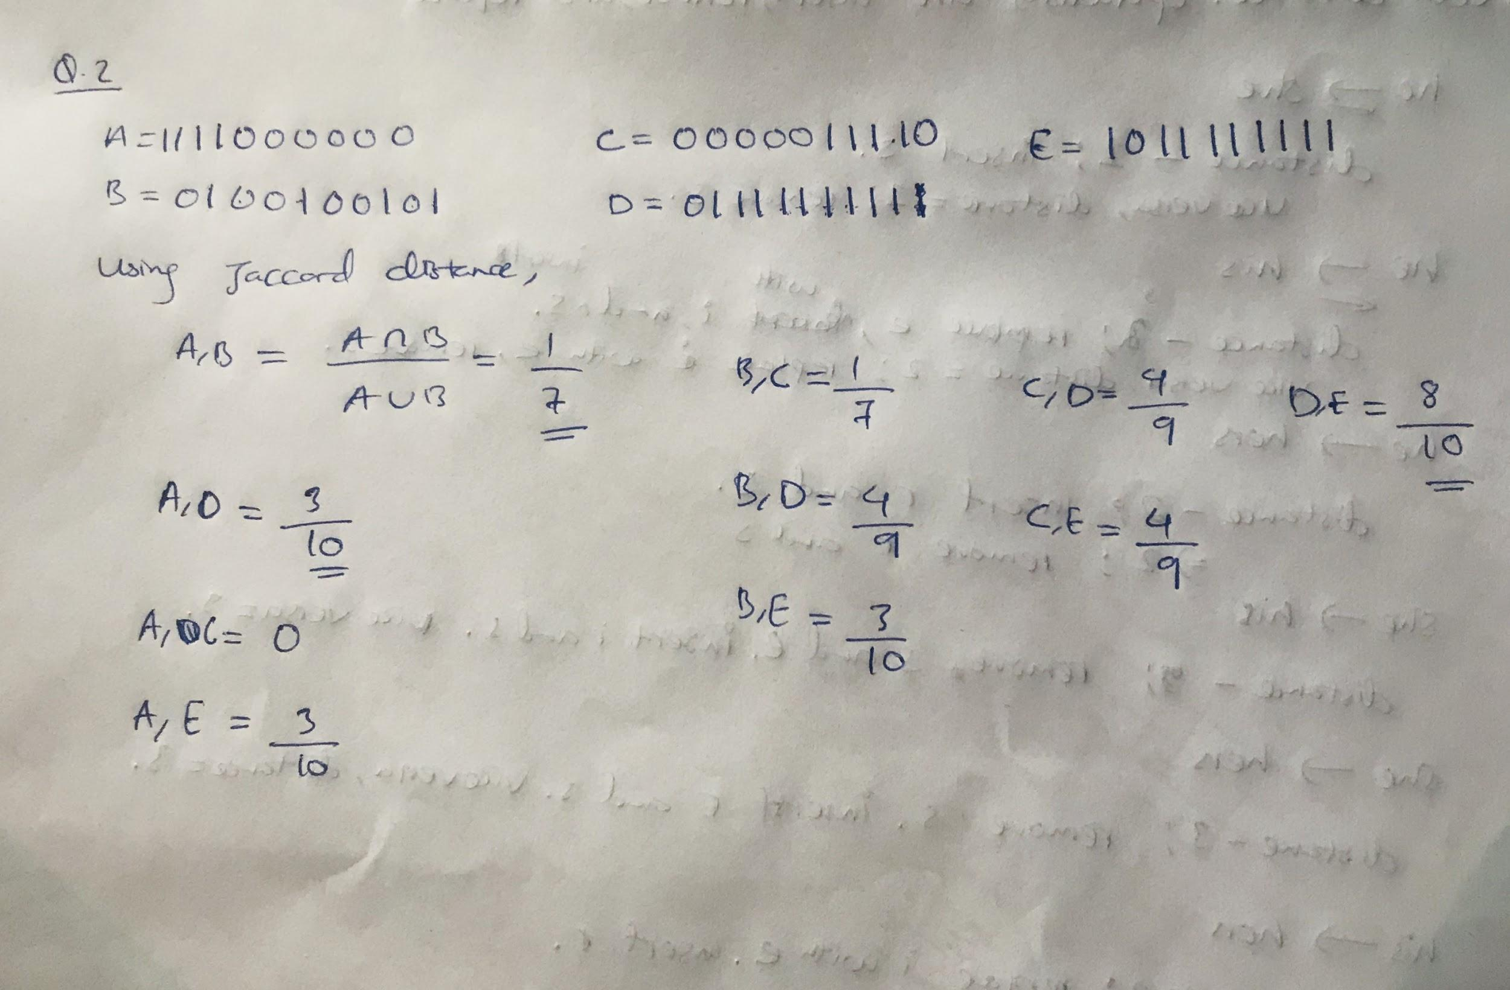

**Question 3**:

Here are five vectors in a 10-dimensional space:

1111000000 0100100101 0000011110 0111111111 1011111111

Compute the Manhattan distance (*L*1 norm) between each two of these vectors.

Ans.

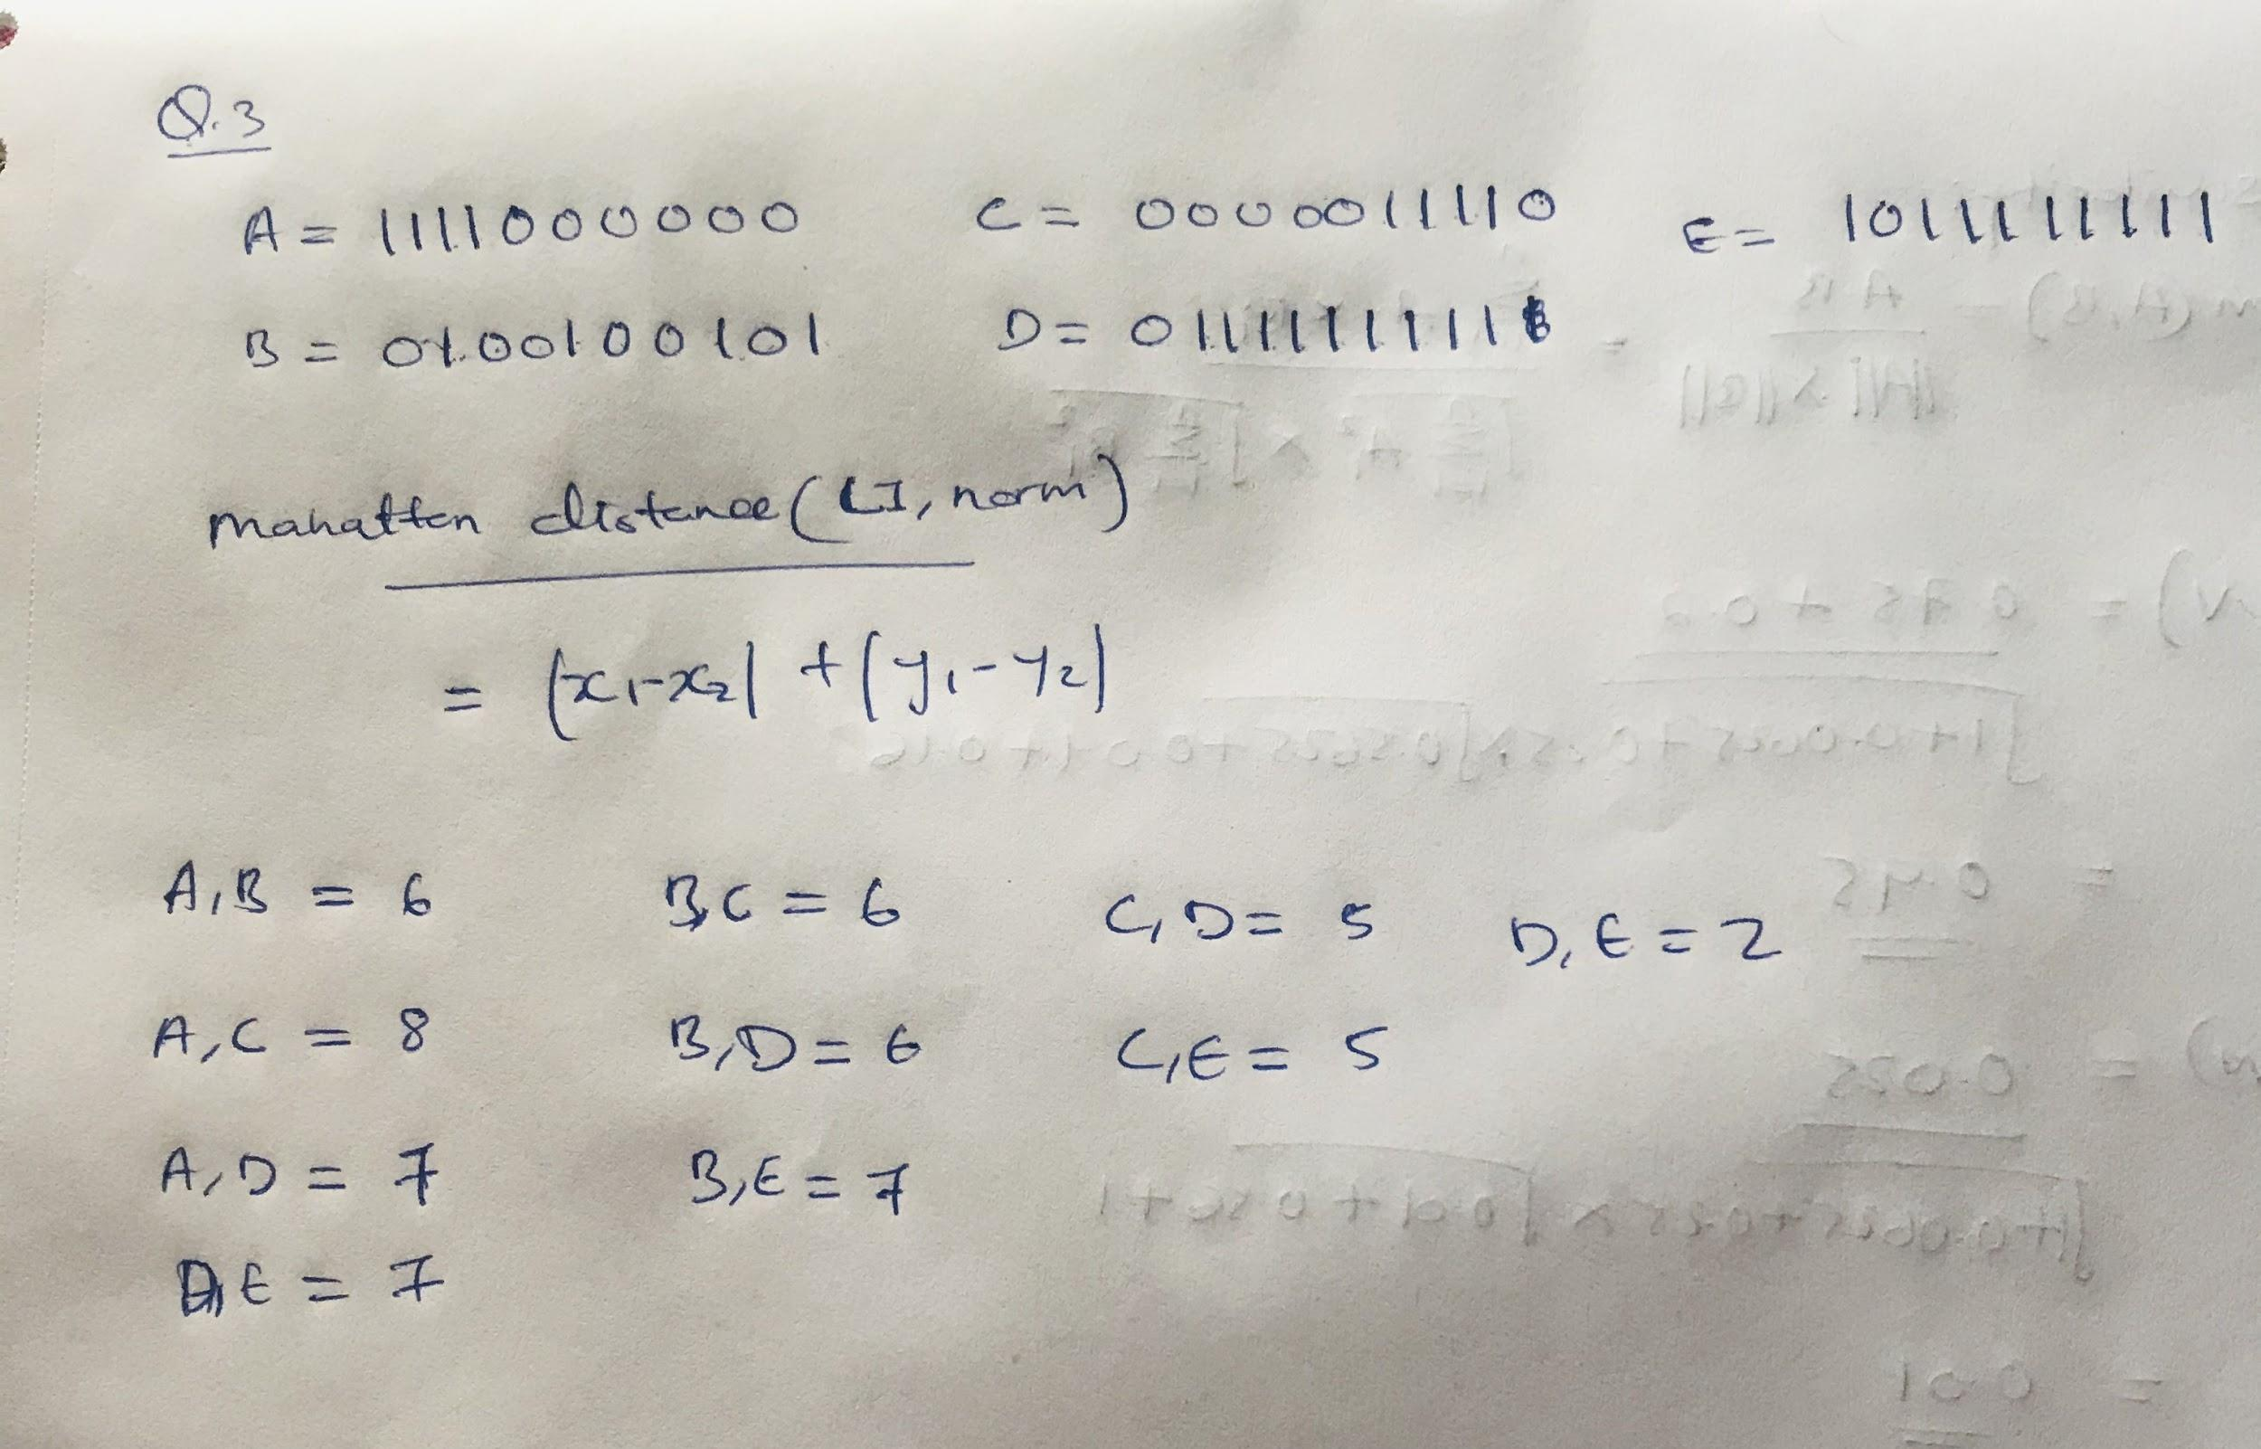

**Question 4**: The edit distance is the minimum number of character insertions and character deletions required to turn one string into another. Compute the edit distance between each pair of the strings **he**, **she**, **his**, and **hers**.

Ans.

